Hi Guys!

Welcome to JEE ZONE youtube channel

Guys you know very well ,every year there are nearly 20,00,000 students are preparing for the various compitative examinations all over india.

Apart from that our central government conducts JEE(mains, advanced) examination to secure admissions into various prestigious institutes like IIT’s, NIT’s, IIIT’s and GFTI’s all over the country.in 20,00,000 of students a maximum of 12,00,000 students are giving the JEE main attempt.

Is your aim is to crack JEE?

Are you fetching the path to full fill your dreams?

Here is the way to full fill your dreams.

JEE ZONE provides the problem solving techniques, material, excersises, mock tests, discussion on previous year questions of JEE and these will help all of you to crack JEE.

Here are the team members of JEE ZONE

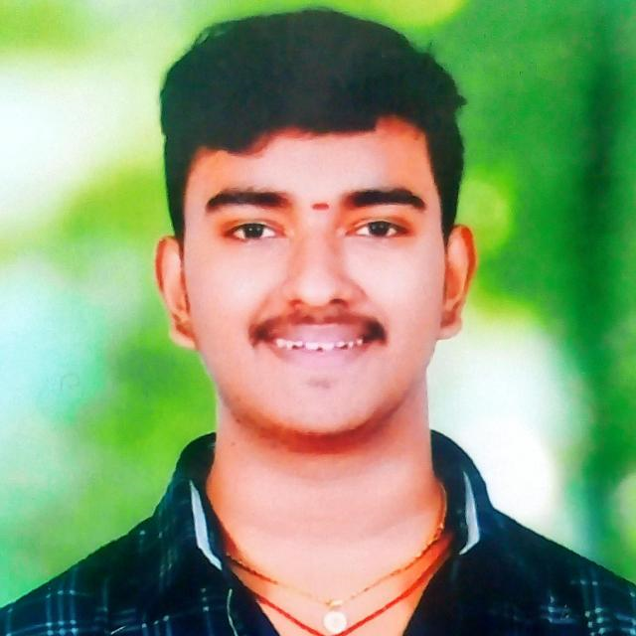 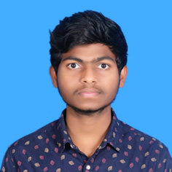 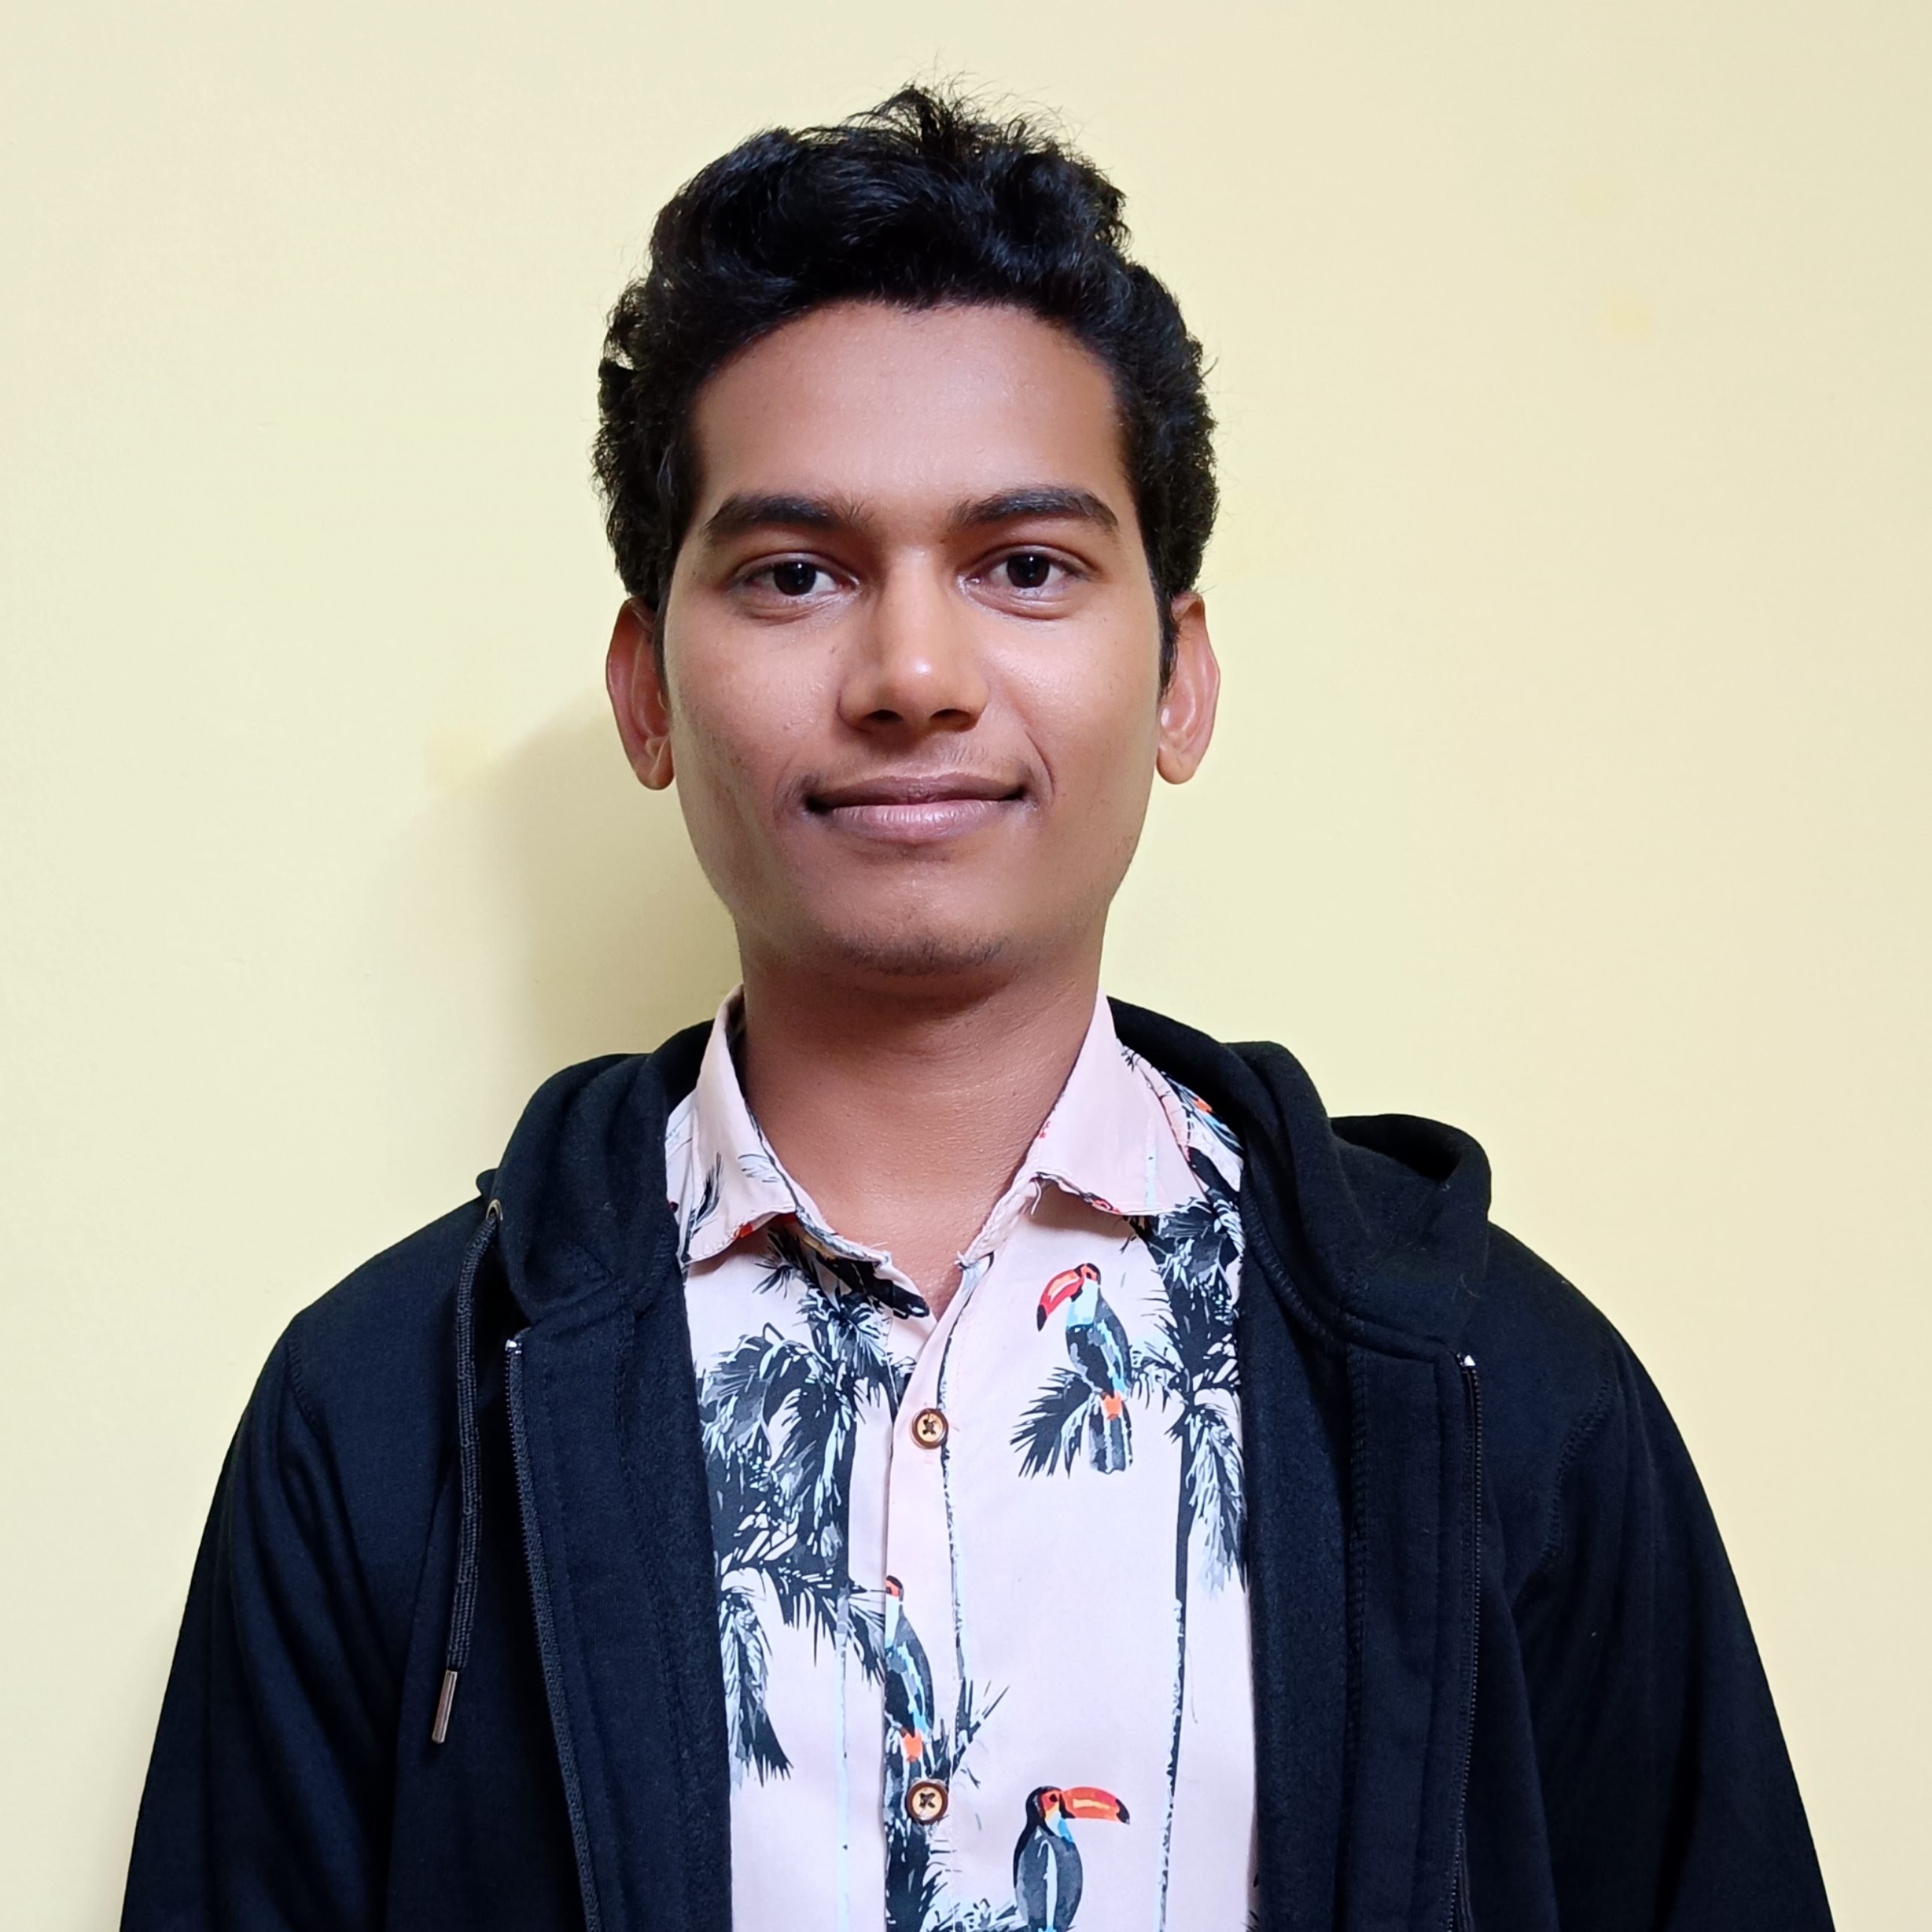

B Prudhvi Ram K Vidya Sagar G Linganna

NIT, Srinagar NIT, Srinagar NIT, Srinagar

B.Tech (C.S.E) B.Tech (E.E) B.Tech (C.S.E)